Lecture 3, AverageReducer, Part 1

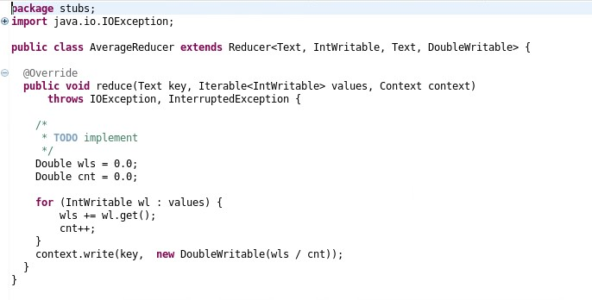

Lecture 3, AvgWordLength Driver, part 1

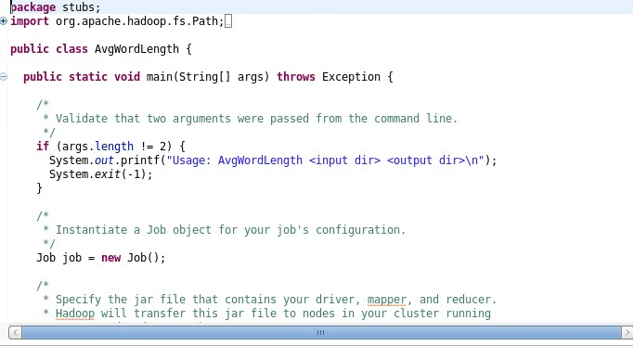

Lecture 3, AvgWordLength Driver, Part 2

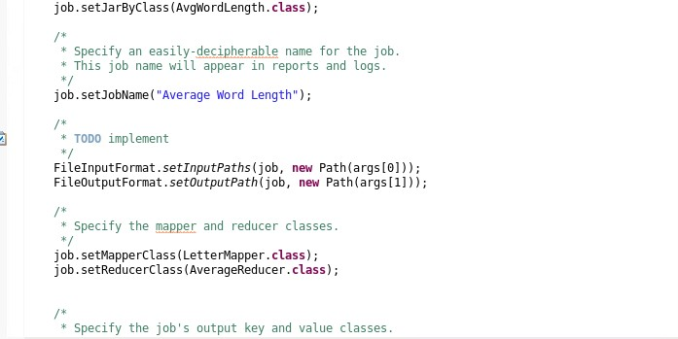

Lecture 3, AvgWordLength Driver, Part 3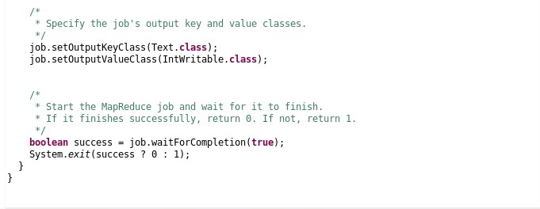

Lecture 3, LetterMapper, Part 1

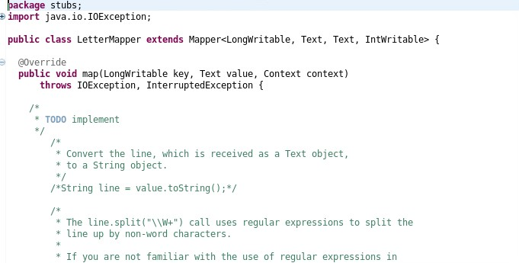

Lecture 3, LetterWrapper, Part 2

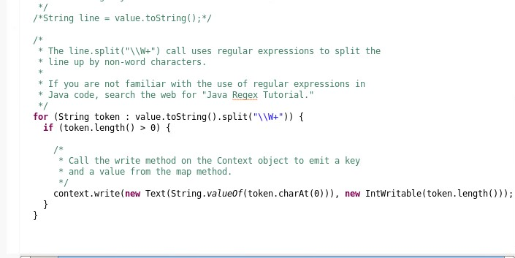

Lecture, Step 3, Part 1

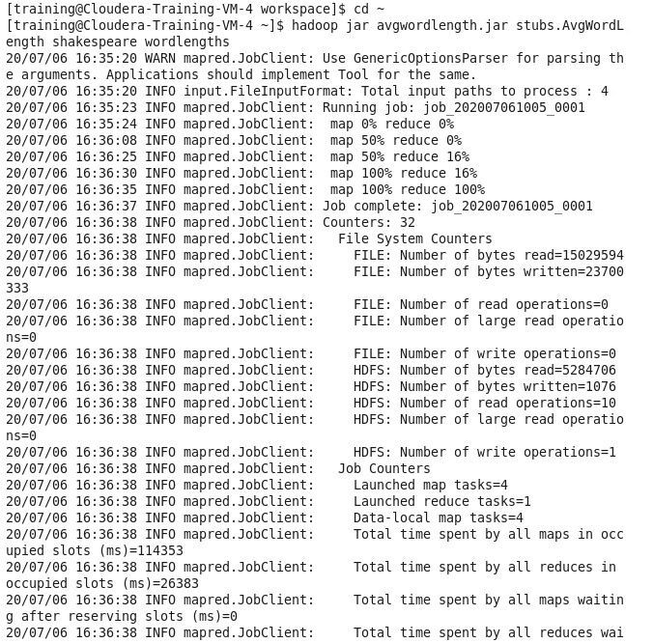

Lecture 3, Step 3, Part 2

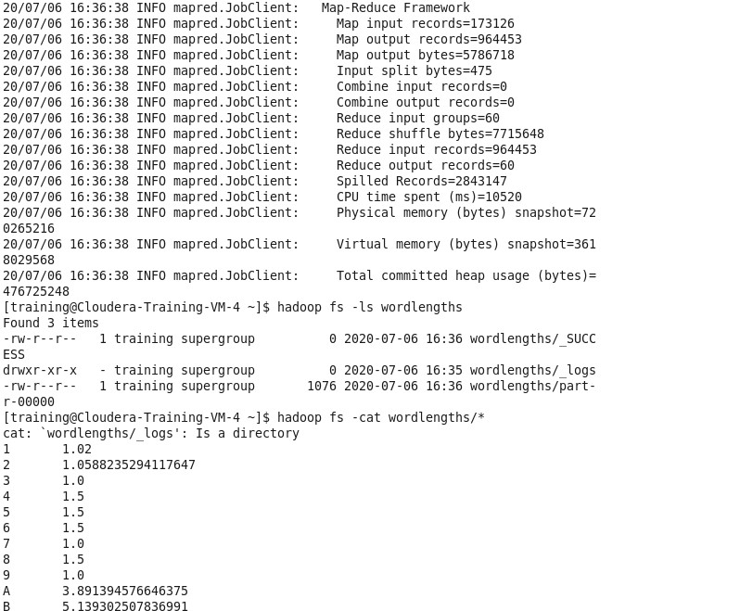

Lecture 7, IndexMapper, Part 1

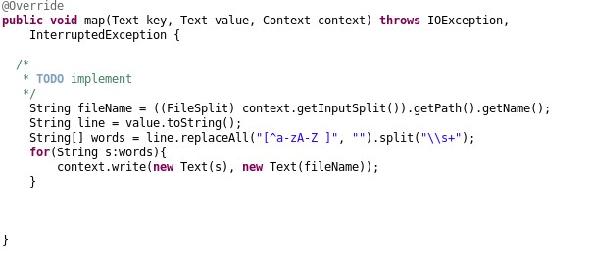

Lecture 7, IndexReducer, Part 1

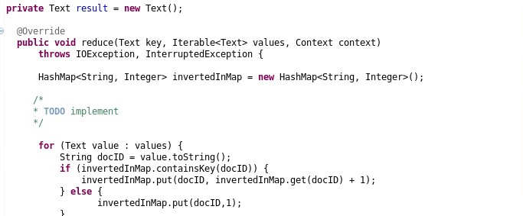

Lecture 7, IndexReducer, Part 2

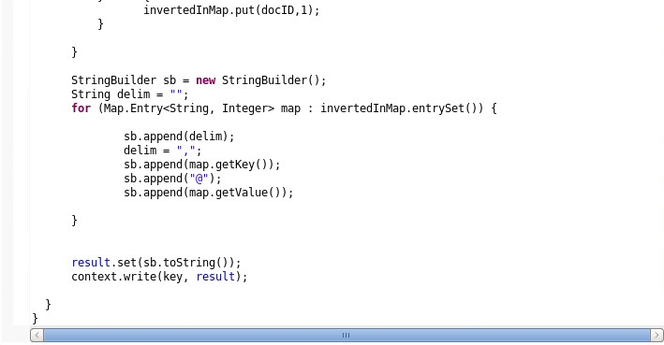

Lecture 7, InvertedIndex Driver, Part 1

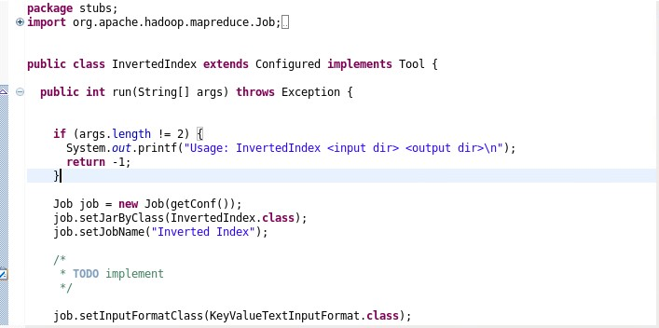

Lecture 7, InvertedIndex, Part 2

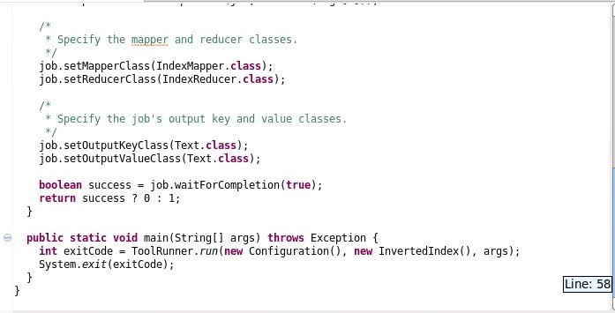

Lecture 7, Step 4

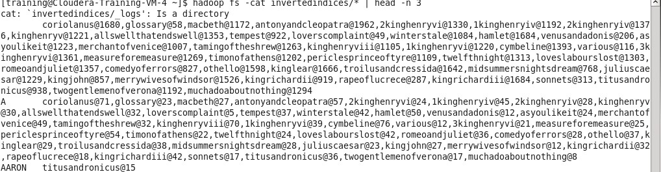

Lecture 8, Step 5, Part 1

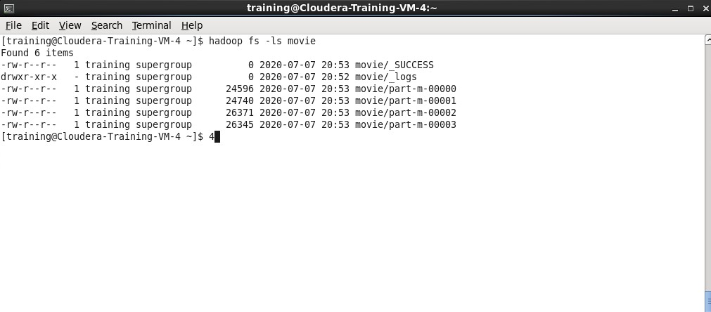

Lecture 8, Step 5, Part 2

